Alexandria University
Faculty of Engineering
Computer Engineering and Systems dept.
4th year
2004-2005

Intelligent Agents

Submitted by:

- Mohamed Abd-ElAziz Khamis (56)

Supervisor:

- Prof. Dr. Amin Shokry

Contents:
- Introduction
- What is an Agent?
- What is a Multi-Agent System?
- Architecture of agents
- Agent societies
- The history of MAS
- The applications of the MAS
- The Agent Communication Language (ACL)
- Conclusion
- Main references used

- Introduction

Intelligent software agents are a new class of software that act on behalf of the user to find and filter information, negotiate for services, easily automate complex tasks, or collaborate with other software agents to solve complex problems.

While agents are useful and powerful computational entities and a single agent can be used to perform a wide variety of tasks, agents are most useful when multiple agents communicate, cooperate and collaborate to solve complex problems. A collection of agents that work together to provide some service is called a Multi-agent system.

The language used by the agents to communicate in the Multi-Agent System is called ACL (Agent Communication Language); there exist two types of ACL’s:
  - Foundation for Intelligent Physical Agents (FIPA) ACL
  - Knowledge Query and Manipulation Language (KQML)

FIPA is a non-profit organization aimed at producing standards for the interoperation of heterogeneous software agents.

The unified language used in modeling the agents’ interaction protocols is called the AUML (Agent Unified Modeling Language)

- What is an Agent?

- Various definitions ...

- Agent = = Intelligence

- Single, intelligent agent → Idea of either 'native' intelligence or
- Multiple simple agents → 'emergent' intelligent by simple agents

- Multiple intelligent agents

- Agent == Autonomy

- Systems that decides by themselves the best action to satisfy their objectives

- Agents that must operate robustly in rapidly changing, unpredictable, or open environments

- Origins (MAS)

Distributed Artificial Intelligence (DAI):
-Distributed Problem Solving (DPS)
-Multi-agent Systems (MAS)

Expert systems

- Broad definition:
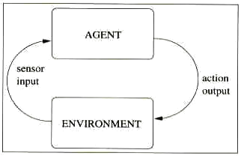

- "Program that takes sensory input from the environment, and produces output actions that affect it."

- Agents:
- Sense their environment
- Choose an action to perform on the environment
- Perform the action on the environment

- Some discriminative criteria:

  - Reactivity: how the agent reacts to its environment
  - Pro-activeness: does the agent take initiatives regarding the evolution of its environment and how
  - Social ability: does the agent interacts with others and how

- Sometimes confusion between the natural notion and the computing applicability

- A taxonomy
  - Simple-reflex agents: basic model of agents, which acts according to a system of "condition-action" rules (no model)

  - Model-based reflex agent: model that in addition to a system of "condition-action" rules integrates a representation of the world

  - Goal-based agent: model that in addition to a representation of the world has goals to reach in this world, and act according to the state of the world and its goals, -> is able of planning

  - Utility-based agent: goal-based agents + finer appreciation of the world (e.g. utilization of real functions rather than boolean evaluations)

  - Learning agent: model of agent that can improve its efficiency by integrating learning capabilities (-> enables it to judge the quality of its actions, and modify its behavior accordingly)

    - Agents design is not independent of their environment

    - Some discriminative criteria:

- Fully/Partially observable: does the environment is completely or partially accessible to the agent?

- Deterministic/Non-deterministic: does the environment evolution is determined by its perceived situation and the agent action? (i.e. does an agent action have a single guaranteed effect)

- Episodic/Non-episodic: does the environment evolution is continuously or by successive episodes?

- Static/Dynamic: does the environment remain unchanged except by the agent action?

- Discrete/Continuous: does the environment contain a finite number of percepts?

- What is a Multi-Agent System?

- General definition:

- Multi-Agent System = = set of agents and the environment they interact

environment
Agent
Agent
Agent
Agent
Agent
Agent
- Purpose(s):

- Expert systems that learn from situations and decisions (no deterministic output)

- Robust systems that resolve unexpected situations, functioning in changing, unpredictable, or open environment

- Distributed systems that model natural approaches

- Some discriminative criteria:

- Homogeneous/Heterogeneous: system composed of identical agents?

- Intelligent/Purely reactive: system composed of reactive agents?

- Communicative/Non-communicative: system composed of interacting agents?

- Application perspectives:
(Can not be used for everything contrary to some beliefs ← lousy definition of agents)

- Systems without centralized control

- Systems decomposable in independent tasks

- Systems composed on independent autonomous entities

- Benefits: (complementary reasons)

- Parallelism: agents execute concurrently

- Scalability: agents can added/withdrawn statically (by the designer)/dynamically (by the system itself), inherent distributed system

- Robustness: agents can modified independently, use of redundant agents (ex: agent with limited capacities)

- Simplicity: individual agent development is simpler than of a monolithic system (complexity moved to interactions?)

- Interactions in MAS:
  - Cooperation
  - Competition

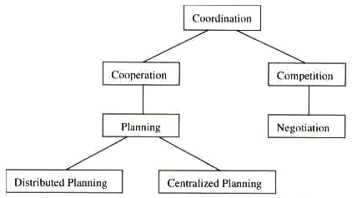

- Learning aspects in a MAS:

- Learning methods
  - Supervised learning: learning is supervised by an external source, agent is giving explicit information about input-output pairs

  - Unsupervised learning: learning is not supervised externally, but by the agent itself (trial and errors)

  - Reinforcement learning: agent supervises its own learning by selecting an action to try and evaluating the results
  - Learning independently (multiple-agent learning): Agent learns independently without sharing any information with other agents

  - Learning socially (social-agent learning): Agent shares perception of the environment, respective policies, or rewards
      - Homogenization
      - Specialization

- Architecture of agents

- A Formal architecture
  - Reactive agents

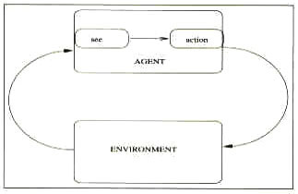

Set S = {s1,s2,...} environment states
Set P = {p1,p2,...} percepts
Set A = {a1,a2,...} actions

Agent: Action: S* -> A
Environment: Env: S x A -> P(S)
Agent perception: See: S->P

  - Agents with states
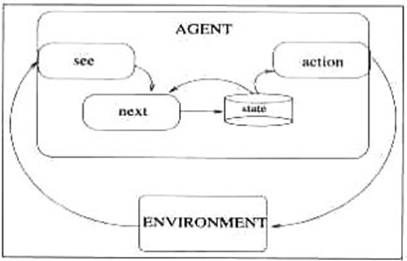

Set S = {s1,s2,...} environment states
Set P = {p1,p2,...} percepts
Set A = {a1,a2,...} actions
Set I = {p1,p2,...} agent's internal state

Agent: Action: I -> A
Environment: Env: S x A -> P(S)
Agent perception: See: S->P
Deliberation: Next: P x I -> I
Functionally identical for the environment

- Logic-Based Architectures

- Use of symbolic representation (from traditional AI)
- Deliberation is realized through logical deduction

- Set of deduction rules ρ

- Action:
for each possible a
if ρ applied on i prove do(a)
return a

for each possible a
if ρ applied on i do not prove not do(a)
return a

return null

- Reactive Architectures

- Reject use of symbolic representation
- No deliberation or interpretation

- Perceptual inputs are directly mapped to actions
- -> need to distinguish priority between behaviors
(ex: subsumption hierarchy (Brooks), where the behaviors arranged into layers)
- Action:
fired = all (p,a) with current p

for each fired
if (c,a) has max priority
return a

return null

- Belief-Desire-Intention Architectures
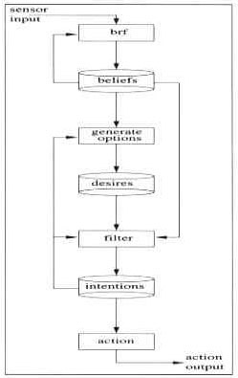
- Based on practical reasoning ("process of deciding, moment by moment, which action to perform")

Belief: what the agent information knows about the environment
Desire: what the agent could do
Intention: what the agent will do

Intentions drive means-end reasoning, persist and constraint future deliberation

Problem: agent regularly needs to reconsider its intentions, so tradeoff between:
- pro-active agents (reconsider rarely)
- cautious agents (reconsider often)
- Others Architectures

  - Layered architectures
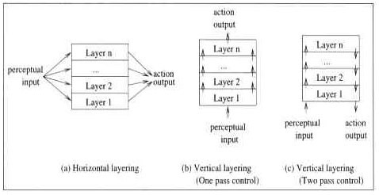
- Horizontal layering
- Vertical layering (one or two pass)

- Agent societies
- Contract Net
- Modeled on the contracting mechanism used by businesses to govern the exchange of services

- Agents are: Manager or contractor

      - Manager: announce task, receive bids, award contract, receive results

      - Contractor: receive announcements, determine if can perform task, respond, perform task, report results
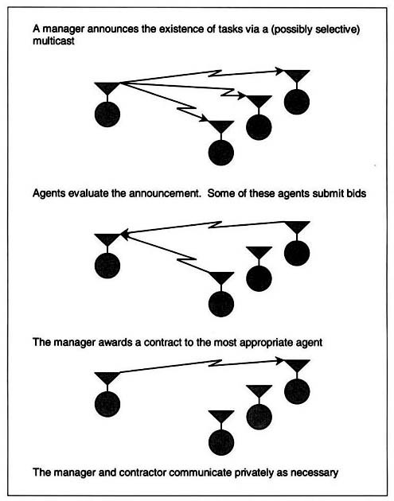

- Blackboard Systems
- Model group of specialist, where a problem is put on the blackboard, and each specialist determines if she/he can do a contribution

- Agents are specialists
Agent
Agent
Agent
blackboard
Agent
...
...

- Constraints:
- Independence of expertise
- Common interaction language
- Diversity on problem solving techniques

- Market Mechanisms
- Model based on market mechanisms, to coordinate activities of many agents with minimal direct communication among the agents
- Approach used for massive MAS

- Agents are: Consumer (exchange goods) or Producer (transform some goods into other goods)

- Agent purpose it is to maximize its profit

- Designer defines of: what goods are traded, what is the bidding and trading behavior of agents, which agents are consumers, producers, how producers change goods

- Simple principle in theory (everything is money, purpose is to maximize gains)
- Other model societies based on:
- Coordination
- Cooperation and/or Competition
- Multi-agent Belief Maintenance
- ...
Interactions in a MAS

- The history of MAS

Software agents have evolved from multi-agent systems (MAS), which in turn form one of three broad areas which fall under DAI, the other two being Distributed Problem Solving (DPS) and Parallel AI (PAI). Hence, as with multi-agent systems, they inherit many of DAI’s motivations, goals and potential benefits. For example, thanks to distributed computing, software agents inherit DAI’s potential benefits including modularity, speed (due to parallelism) and reliability (due to redundancy). It also inherits those due to AI such as operation at the knowledge level, easier maintenance, reusability and platform independence (Huhns & Singh, 1994).

The concept of an agent can be traced back to the early days of research into DAI in the 1970s - indeed, to Carl Hewitt’s concurrent Actor model (Hewitt, 1977). In this model, Hewitt proposed the concept of a self-contained, interactive and concurrently-executing object which he termed ëactorí. This object had some encapsulated internal state and could respond to messages from other similar objects: an actor

- The applications of the MAS

  - A Bidding system:
There exist specific agents to achieve:
    - The role of the auctioneer.
    - The role of the bidder.

  - A Network management system:
There exist specific agents to achieve:
    - Dynamic bandwidth management
    - Fault restoration
    - Spare capacity planning

  - A Teleteaching project (using the FIPA protocol):
There exist specific agents to achieve:
    - Companion agent: assists a student by providing a graphical user interface
that will help interact with other agents and mostly with the tutor agent.
    - Tutor agent: provide assignments
    - Verificator agent: analyze the validity and coherence of a proof given by a
student.

  - A Hotel Service Broker system (using FIPA protocol)
An agent accessing the system services can:
    - Search for hotels satisfying some given conditions.
    - Retrieve information about these hotels
    - Finally book these hotels.

  - An Agentcities Travel Assistant:
A multi-agents system that delivers itinerary timetables (FIPA protocol application)

  - A Multiagent Network Security System using FIPA-OS

  - An e-banking services for Automated Agent-Based trading
An electronic banking transactions MAS using the FIPA-ACL protocol

  - A Proxy-Bidding Strategies where agents communicate using FIPA-compliant
messages

- ACL: Agent Communication Language

An ACL (agent communication language) provides language primitives that implement the agent communication model. ACLs are commonly thought of as wrapper languages in that they implement a knowledge-level communication protocol that is unaware of the choice of content language and ontology specification mechanism.

Nearly all the ACLs around derive their language primitives from the linguistic theory of speech acts. Speech act theory categorizes human (or machine) "utterances" into different categories depending on the intent of the speaker (human or agent), the effect on the listener (human or agent), and any other physical manifestations of the act of uttering the utterance. Since speech acts are a human knowledge-level communication protocol, it is felt that they would be effective as an agent communication protocol, esp. since agents might operate on behalf of humans. However, the case has also been made for speech acts as appropriate programming language primitives for next generation programming languages (not just ACLs) [McCart92].

There exist two types of ACL’s:

Knowledge Query and Manipulation Language (KQML):

The architecture underlying KQML is that of a community of agents, each owning and managing a virtual KB (VKB) that represents its mental model of the world. KQML doesn't care about the content language used to represent the mental model (could be KIF, RDF, SL or some other content language). Its goal is to provide knowledge transportation protocol for blobs of content, in some ontology that the sending agent can point to and the receiving agent can access. Agents then query and manipulate the contents of each others VKBs, using KQML as the communication and transport language. KQML presupposes a white-box (or at least gray-box) model of agent community VKBs, and includes direct edits to an agent's VKB by another agent as part of its language primitives.

Foundation for Intelligent Physical Agents (FIPA) ACL:

FIPA’s agent communication language, like KQML, is based on speech act theory: messages are actions or communicative acts, as they are intended to perform some action by virtue of being sent. The FIPA ACL specification consists of a set of message types and the description of their pragmatics—that is, the effects on the mental attitudes of the sender and receiver agents. The specification describes every communicative act with both a narrative form and a formal semantics based on modal logic. It also provides the normative description of a set of high-level interaction protocols, including requesting an action, contract net, and several kinds of auctions.

- Conclusion:

- Everything can not be done with agents (or use of meta-agents?)

- Agents embody the ideas of autonomy and intelligence

- MAS interesting because "intelligence and interaction are deeply and inevitably coupled, and multi-agent systems reflect this insight" (Weiss)
- Multi-agent system approach is parallel to the goals of a distributed, possibly heterogeneous system, which focus on extensibility, configurability, self-diagnostic, and high platform independence

- Autonomous and intelligent components favor resilience and extensibility, by enabling the dynamic addition of agents, the modification of existing agents independently of the system utilization, and the development of new agents to resolve new issues of the system
system
Agent
Agent
Agent
Agent
Agent
Agent
Agent

- However:

- Lack of methods for AOSE (Agent-Oriented Software Engineering)
- AOSE methods approach use a new 'paradigm' (program agents in terms of mentalistic notions -such as belief, desire, and intention- , Weiss)

- Maybe too high level approach (MASs consider highly independent, autonomous and intelligent components that are able to learn from experience)
- As mentioned before, Agents embody the ideas of autonomy and intelligence

- Need to reconsider system in terms of agents

- Main references used
- Multiagent Systems: A Modern Approach to Distributed Artificial Intelligence. Gerhard Weiss (ed), MIT Press

- Some readings on Multi-Agent Systems (draft). P.E. Poirot

- Algorithms for Learning in Multiple-Agent Systems (in french). Nicolas Pernot, Mohamed Elati. Université d'Orsay - Paris XI. http://www.limsi.fr/Individu/jps/enseignement/examsma/2004/PERNOT_ELATI/

- Modeling civil violence: An agent-based computational approach. J. M. Epstein. http://www.pubmedcentral.nih.gov/articlerender.fcgi?artid=128592&rendertype=abstract

